31.22: a) First, let us find the phase angle between the voltage and the current
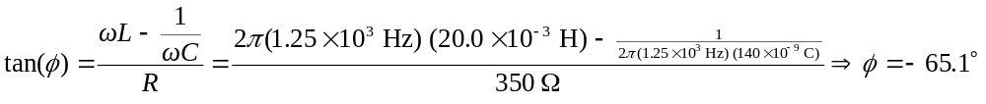The impedance of the circuit is
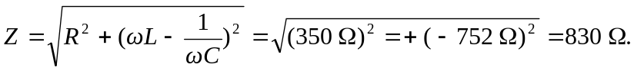
The average power provided by the supply is then
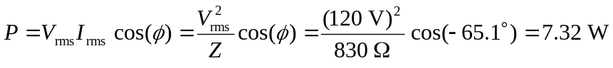
b) The average power dissipated by the resistor is 